**Lab 3: Web_API_HandsOn**

1. **Web Api using custom model class**

**CODE:**

**Employee.cs**

**using System;**

**using System.Collections.Generic;**

**namespace SwaggerApiDemo.Models**

**{**

**public class Employee**

**{**

**public int Id { get; set; }**

**public string Name { get; set; }**

**public int Salary { get; set; }**

**public bool Permanent { get; set; }**

**public Department Department { get; set; }**

**public List<Skill> Skills { get; set; }**

**public DateTime DateOfBirth { get; set; }**

**}**

**public class Department**

**{**

**public int DeptId { get; set; }**

**public string DeptName { get; set; }**

**}**

**public class Skill**

**{**

**public int SkillId { get; set; }**

**public string SkillName { get; set; }**

**}**

**}**

**EmployeeController.cs**

using Microsoft.AspNetCore.Authorization;

using Microsoft.AspNetCore.Mvc;

using SwaggerApiDemo.Models;

namespace SwaggerApiDemo.Controllers

{

[ApiController]

[Route("api/[controller]")]

[AllowAnonymous] // Allow access without auth for now

public class EmployeeController : ControllerBase

{

private List<Employee> GetStandardEmployeeList()

{

return new List<Employee>

{

new Employee

{

Id = 1,

Name = "John",

Salary = 50000,

Permanent = true,

DateOfBirth = new DateTime(1990, 1, 1),

Department = new Department { DeptId = 1, DeptName = "HR" },

Skills = new List<Skill>

{

new Skill { SkillId = 1, SkillName = "C#" },

new Skill { SkillId = 2, SkillName = "SQL" }

}

},

new Employee

{

Id = 2,

Name = "Jane",

Salary = 60000,

Permanent = false,

DateOfBirth = new DateTime(1992, 5, 10),

Department = new Department { DeptId = 2, DeptName = "IT" },

Skills = new List<Skill>

{

new Skill { SkillId = 3, SkillName = "JavaScript" }

}

}

};

}

// ✅ GET: api/employee/standard

[HttpGet("standard")]

[ProducesResponseType(typeof(List<Employee>), 200)]

public ActionResult<List<Employee>> GetStandard()

{

return Ok(GetStandardEmployeeList());

}

// ✅ POST: api/employee

[HttpPost]

[ProducesResponseType(200)]

public IActionResult PostEmployee([FromBody] Employee emp)

{

return Ok($"Received Employee: {emp.Name}");

}

}

}

**Swagger UI Screenshot:**

**GET REQUEST:**

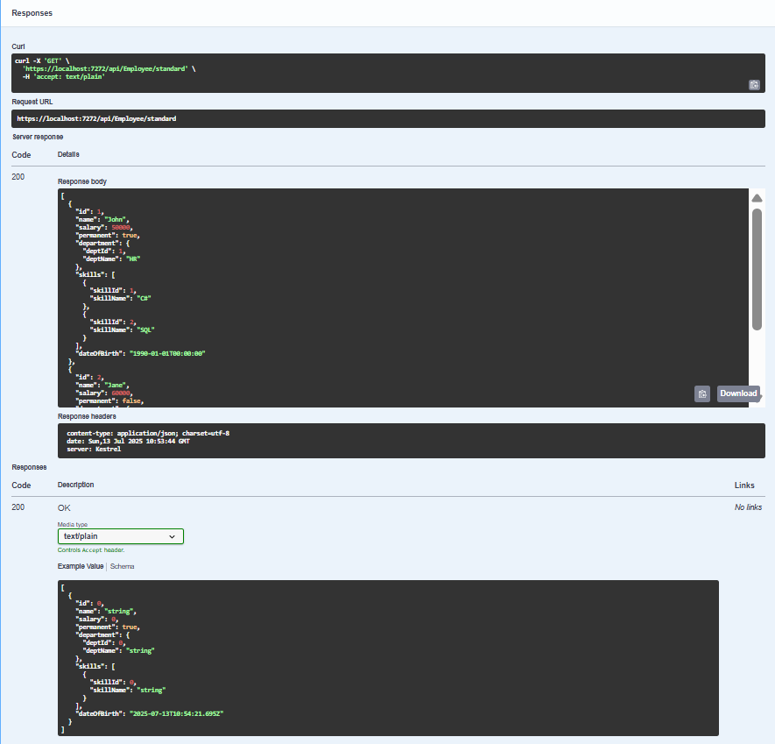

**POST REQUEST:**

1. **Create a Custom action filter for Authorization.**

**Without Authorization**

1. **Custom Authorization Filter  
     
   Code:**

**using Microsoft.AspNetCore.Mvc;**

**using Microsoft.AspNetCore.Mvc.Filters;**

**namespace WebAPIDemo.Filters**

**{**

**public class CustomAuthFilter : ActionFilterAttribute**

**{**

**public override void OnActionExecuting(ActionExecutingContext context)**

**{**

**if (!context.HttpContext.Request.Headers.TryGetValue("Authorization", out var authHeader))**

**{**

**context.Result = new BadRequestObjectResult("Invalid request - No Auth token");**

**return;**

**}**

**if (!authHeader.ToString().Contains("Bearer"))**

**{**

**context.Result = new BadRequestObjectResult("Invalid request - Token present but Bearer unavailable");**

**}**

**}**

**}**

**}**